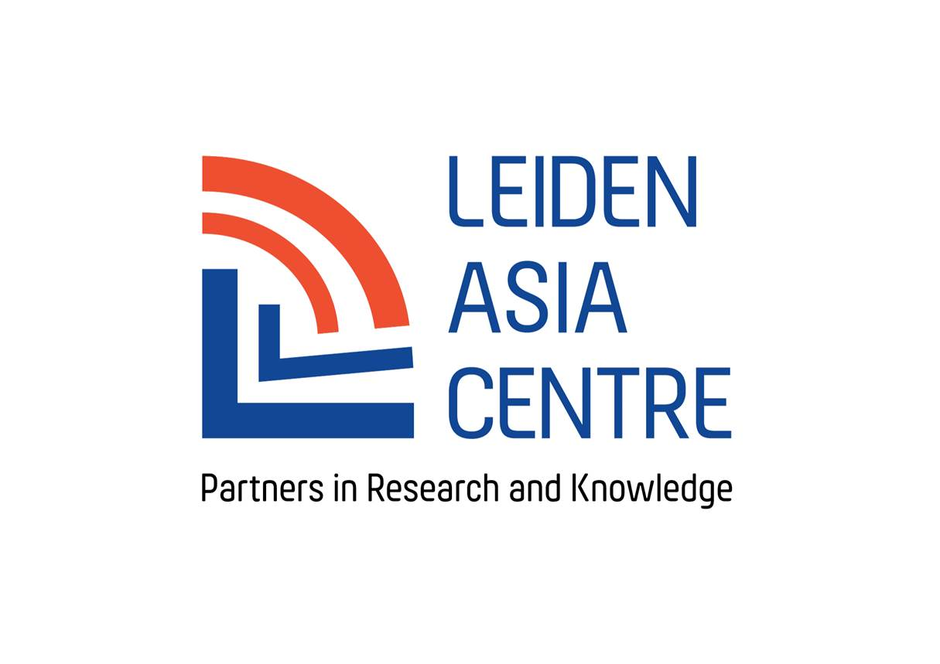

LEIDEN ASIA CENTRE
Annual report 2017

Content:
- Introduction and mission 2
- Governance 3
- Research 4
  - Current projects
  - New proposals
- Outreach 10
  - General outreach
  - Outreach activities
    - 2015
    - 2016

- Finances 12
- Partners 13
- Composition of Sounding Boards 13
7.1 China and the Netherlands sounding board
7.2 Slaves of the system sounding board

- Introduction and Mission

The 21st century is often regarded as the age of Asia. It is projected that the Asian region as a whole will continue to dominate global developments in terms of politics and culture, as well as economic and demographic shifts. Leiden University is well-placed to study and interpret these developments, owing to the longstanding links with and rich experience in investigating Asia.
In 2015 the Modern East Asia Research Centre (MEARC), was transformed into an expertise centre for socially relevant and applicable knowledge on modern East Asia. The LeidenAsiaCentre aims to expand its expertise and to do so in collaboration with a growing number of societal partners, in particular the business sector, civil society, the media, government and academic and non-academic knowledge centres.
The LeidenAsiaCentre achieves this by:
- Consulting with non-academic partners in identifying research questions;
- Conducting original academic research, taking into account the needs of stakeholders in society;
- Building and expanding a broad network within the Dutch government, the media, educational institutions, the business sector and civil society;
- Disseminating knowledge by means of lectures, conferences, intensive training courses and publications, including web publications.

In 2014 the Modern East Asia Research Centre (MEARC) received a grant of several millions euros through the Leiden University Fund. The grant originated from the Vaes-Elias Fund.
The Board of MEARC together with the three directors decided to use these funds to put MEARC on a completely new footing including a change of governance structure as well as a change of name. The LeidenAsiaCentre was officially launched in January 2016.

- Governance
In the course of 2015-2016 the LeidenAsiaCentre underwent a governance transformation resulting in an autonomous Executive Board (Bestuur, consisting of the current three directors) with oversight being provided by the Supervisory Board. This still holds true in 2017.
The mandate of the Executive Board has been widened and the Supervisory Board’s (Raad van Toezicht) main task is to see to it that activities undertaken by the LeidenAsiaCentre reflect the policy decided upon by the various governing bodies of the centre.
In addition to the Supervisory Board it was felt that the overall strategy of the LeidenAsiaCentre would benefit from the input of an International Advisory Board. Consisting of academics and executives working on (East) Asia and drawn from a variety of disciplines and perspectives, this body will meet once a year to review the research and outreach activities of the centre, to advise on relevant developments and to strengthen the LeidenAsiaCentre network.
Members of the Supervisory Board as of January 2018:
- Mr. André van Heemstra (Chair)
- Prof. Mark Rutgers, Dean Faculty of Humanities, Leiden University
- Mrs. Stan De Klerk-Waller, Chair of the Leids Universiteits Fonds (LUF)
- Dr. Ben Knapen

Members of the International Advisory Board as of January 2017:
- Prof. Bill Callahan (LSE)
- Prof. Valerié Gélèzeau (EHESS/IIAS)
- Prof. Emiko Ochiai (Kyoto University)
- Prof. Gert Oostindie (KITL V)
- Dr. Philippe Peycam (IASS)
- Prof. Jennifer Robertson (University of Michigan, Ann Arbor)
- Dr.Monika Sie Dhian Ho (Netherlands Institute of International Relations Clingendael)
- Lay Hwee Yeo (European Union Centre/ Singapore Institute of International Affairs/ National University of Singapore)

- Research
The LeidenAsiaCentre has expressed its ambition to become the leading centre of applied knowledge with respect to Asia. Our focus is primarily on East Asia: China (including Taiwan), Japan, Korea, Singapore and, since recently, Vietnam.
The selection of research topics is directed towards developments with direct relevance for either Europe or the Netherlands. Emphasis is on the nature and consequences of globalisation that leads to an increased intertwining between Asia and Europe in the broadest sense: economically, culturally, politically and strategically.
What distinguishes LeidenAsiaCentre from other Asia-oriented research centres is the way in which stakeholders from society are involved at each stage of a project. All projects which commenced after 2015 are conducted under the following model. Research is only initiated when interest outside academia has been clearly identified. Only when partners indicate their commitment to a selected theme will funds be made available. This ensures that the research reflects specific concerns within Dutch society - more broadly - and that the results are being disseminated among a variety of non-academic circles. Researchers are mostly hired from outside Leiden for a short period of time (3 to 12 months) or work free-lance. A flexible number (3-6) of interns and student-assistants are part of each team. The centre’s fulltime manager is in charge of the daily business of the centre and support of the project teams.
This approach has resulted in many reports on a variety of topics and several conferences, presentations and public speeches. Working with partners outside of academia has proven worthwhile. It has given us access to new sources of information, made us ask different questions and look at matters from angles that might have been neglected otherwise.
In addition the LeidenAsiaCentre lends support, both in terms of finance and organisation wise to initiatives from either Leiden University or other third parties that are complementary our own research agenda.

3.1 New projects for 2018
2018 will be an exciting year for the LeidenAsiaCentre, as it will undertake the most projects ever undertaken in one year. Focussing on current issues, such as China’s higher education, the upcoming Olympic Games, and Corporate Social Responsibility in Asia, has ensured that the LeidenAsiaCentre again is working with many different societal partners.

1. The Road to Tokyo 2020: Access to sports for the disabled in Japan and The Netherlands
The next edition of the Olympic and Paralympic Games is going to take place in 2020, Tokyo, Japan (Tokyo 2020). In the run-up to this major sports event, various sports organizations have taken up social responsibility projects, among others the Netherlands Olympic Committee and Netherlands Federation for Sports (NOC*NSF). LeidenAsiaCentre has been granted access by the NOC*NSF to their social inclusion project aimed at the Tokyo 2020 Games. This project targets access to sports for disabled persons in Japan.
LeidenAsiaCentre has been requested to provide a scholarly interpretation of the Japanese context with regard to social issues surrounding disabled persons and sports. In this context and in consideration of the project participants’ goals, the question the proposed research attempts to answer is: How is access to sports for disabled persons institutionally configured and influenced by dominant discourses on disability in Japan, and how do social projects targeting social inclusion in sports for disabled persons function in this context?
The Game Changer project is initiated by the NOC*NSF, the main partner of the LeidenAsiaCentre in this project. Several Japanese organizations such as the Japan Sport Council and local municipalities have expressed a desire to restructure their sports’ institutions based on what is perceived as the ‘Dutch model’. The Game Changer project’s main aim and slogan is to “use sports to change society” (supōtsu wo tsūjite shakai wo kaeru). Combining visits from Dutch experts and Paralympians to Japan, and reverse trips of Japanese government officials to Dutch sports facilities, the project aims to “share knowledge” for the improvement of sports access for disabled athletes.
Project leader: Anoma van der Veere MA

Academic Partners: Paul Hover,Pim Mulier Instituut, Sam Geijer (HvA)

Societal Partners: NOC*NSF, Embassy of The Netherlands in Japan, Japan Sport Council (JSC), Nippon Foundation: Paralympic Support Centre, Japanese Paralympic Committee, Dutch Ministry of Foreign Affairs,

2. Europe and China
In 2016, the Leiden Asia Centre conducted a research project on China and the Netherlands. The focus of the project was the increasing impact of Chinese students, tourists and companies on the economy and society of the Netherlands. Chinese are the second-largest nationality among foreign students in Dutch higher education. Every year, about 250,000 Chinese tourists visit. Chinese investments are rapidly rising, including some very large takeovers, particularly in the past few years. As there was very little existing literature at the time, the project was explorative and mainly descriptive in nature with a view to provide information to Dutch stakeholders. With the information from the reports on our project we are now in a position to propose a new project with a broader scope and sharpened focus.
This follow up project will consist of two different sub-projects that will be carried out simultaneously, namely:
1. Strategic impact of Chinese investment in Europe
2. Impact of China on research, innovation and academic freedom in Europe
The Chinese Communist Party is again tightening its grip over China’s political system and society. In addition, there are indications that the engagement of Chinese institutions and individuals with foreign partners is increasingly tied into a strategic approach coordinated by the authorities in Beijing. Understanding the scope, inclusiveness, objectives and further development of this vision is urgently needed in Europe, if we are to develop an adequate response to China’s impact on our continent. It will not suffice to state that we should or should not be worried and conclude that we should either try to close the door on China or, alternatively, not interfere and let things take their own course. Either response is based on preconceptions and a lack of an empirically grounded understanding of the nature of China’s strategic vision of Europe. This project aims to conduct the research needed to provide this understanding.
Project leader: Frank Pieke
Researchers: Frans Paul van der Putten (Clingendael) Ingrid d’Hooghe (UL), Annemarie Montulet (KNAW), Tianmu Hong, Matt Fercher
Intern: Joris van Schie
Societal Partners: (1) Ministry of Foreign Affairs, Ministry of Economic Affairs, Ministry of Security and Justice, NFIA, VNO-NCW, Institute Clingendael,. (2) Ministry of Education and Culture;; KNAW; NWO; TNO; VSNU; NUFFIC, HCSS

3. Resolving labour shortages? The digital transformation of working practices in the Japanese service sector
This project will explore the degree to which the so-called ‘digital economy’ including automation and robotisation is able to resolve problems associated with the shortage of labour in the Japanese service sector (food and transportation/logistics). Japan is particularly well-suited for such a study due to its combination of being one of the advanced industrial democracies that has experienced the ageing population and the labour shortage issue most acutely, and also due to it having an advantage in terms of the relatively advanced development of its digital economy. The service sector is particularly relevant in this context, as it tends to be labour-intensive. In 2012 over 75 percent of the Japanese workforce was employed in the service sector generating nearly 70 percent of the country’s GDP. The main aim of the project is to demonstrate how the advancement of the digital economy in the service sector has changed working practices and the working environment, and seeks to identify whether the advancement of the digital economy will propose a solution to the challenge of labour shortage in the long-term.
This project will focus on two industries within the service sector: food industry and transportation/logistics industry. These two industries are chosen due to their importance not only to the Japanese economy but also to the Dutch economy.
Project leader: Dr. Saori Shibata

4. CSR in Asia: On paper and in Practice
According to the Global Slavery Index (GSI), workplaces in Asia are responsible for over 2/3 of global slavery and human trafficking. Not only are these numbers staggeringly high, they also allude to labour issues related to slavery and human trafficking, such as poor work safety. To try and ensure that tragedies do not occur and that international agreed standards are respected, many corporations have so called Corporate Social Responsibility (CSR) policies, which vary per company in length, detail and topics.
This project aims to analyse the functioning of CSR in value chain responsibility in Asia, both on paper and in practice. This research aims at analysing case studies about the current state of CSR in South and East Asia, its best-practices and shortcomings, and what is needed for more effective and efficient CSR in the region.
This research, a joint effort of LeidenAsiaCentre and Mondiaal FNV, will focus on the policies of first tier suppliers/manufacturers, and, where possible, also second. Mondiaal FNV is not only expert in CSR regulations, it also has researchers and monitors in Asia, creating a hands-on research project with accessible source material.
To narrow the scope, this research will focus on two case studies within two sectors notorious for labour violations; construction and textile industry.
1. CSR and chain liability in regional projects in South Asia under the Asian Development Bank, the Asian Infrastructure and Investment Bank and the World Bank
This pillar will focus on construction projects in South Asia set up by any of the above-mentioned banks, with a specific emphasis on project bids won by companies from Japan, China and South Korea. Many of the projects that the ADB, the AIIB and the WB finance, are won in bids by corporations in East Asia. East Asian presence in South Asia is enormous, so projects executed by East Asian companies will be one of the key prerequisites when picking case studies for the construction pillar, as these are often also the largest projects.
2. CSR and chain liability: the case of North Korean-made textiles/garments both within the country and abroad
The second pillar is a clear defined case study, which delves into the product chain of North Korean-made textile products, which are often sold as ‘made in China’. The garments are both made within North Korea, but also in Chinese factories that employee North Koreans. This case will investigate CSR responsibility in particular meeting international human rights obligations as laid out in the OECD guidelines for multinationals/UN Guiding principles.

Project leader: Prof. Dr. Remco Breuker, Project coordinator: Imke van Gardingen
Researchers:, Chris de Bock, Jonne Vogelaar, Michael Lee.
Student-assistant: Marieke Meurs
Societal Partners: Mondiaal FNV, Nederland, Asscher Institute,

5. Leiden Network for Japanese Constitutional Research
Constitutional revision is again on the political agenda in Japan, with Prime Minister Shinzō Abe announcing that he would like to see revision by 2020. There are perhaps good strategic reasons to place revision on the agenda. The constitution’s Article 9 was written after the Second World War to limit Japan’s military capability. However, strategic developments, including China’s increased naval activity and North Korea’s nuclear program have, according to revisionists, made Japan’s military restrictions obsolete. Despite this focus on strategy in broader public debates, Abe has made it clear in his writings that he also sees revision as connected to a sense of national pride and identity.
Aligned against revision, meanwhile, is an array of intellectuals and activists either keen to preserve the pacifist elements of the constitution or concerned that Abe’s approach to constitutionalism erodes the rule of law. While constitutional revision looks more likely than ever before, it is hardly a foregone conclusion.
This project proposes to highlight the topic of debate on the constitution in Japan by establishing a Leiden Network for Japan Constitutional Research.
It will aim to encourage debate on Japan’s constitution from a number of perspectives, to provide access to resources on constitutional practice and revision that are not yet available in English, to facilitate research into the domestic implications of the constitutional debate, and to bring into focus the significance of this debate for the political authority of human rights in Asia.

Project leaders: Dr. Bryce Wakefield and Dr. Erik Herber
Societal Partners: TBA

3.2 Research in 2017
Themes and projects
The LeidenAsiaCentre organizes its research projects within wider core themes. Our three core themes in 2017 were:
- Europe and Asia
- People, rights and human rights
- Lifestyle and culture.

    - Europe and Asia
Asia is becoming more directly and visibly present in Europe; and conversely Europe is becoming more prominently present in Asia. This is particularly valid for East Asia. Japanese, South Korean and Taiwanese companies have been established in Europe for decades. Over the past ten years these have been joined at a rapid rate by companies from China. The same applies to tourists, students and (knowledge) immigrants, for whom Europe is becoming increasingly important as a destination. Conversely, European investments, students, tourists, expats and migrants are becoming more prominently present in East Asia. What are the consequences of this growing exchange of people between two of the world’s most densely populated areas? What are the resulting possibilities and challenges for individuals, organisations, companies and governments in European countries? Our research in this field focuses first on connections between China and the Netherlands and will at a later stage be broadened to East Asia and Europe. The following projects have been implemented so far under this theme:
China in the Netherlands
This project comprises three sub-projects:
- Chinese investments and companies in the Netherlands
- Chinese students and knowledge migrants/expats in The Netherlands
- Chinese tourism in the Netherlands

Project leaders: Prof Dr Frank Pieke and Garrie van Pinxteren
Researchers: Bei Wang, Prof Dr Pál Niyri, Tianmu Hong, Trevor Stam
Interns and student-assistents: Jialu Zhang, Julin van Velthuizen, Laurens Steehouder

2. China’s role in regulating cyberspace (January 2017- February 2018)
The rapid development of information and communication technologies (ICTs) and the emergence of China as a primordial global power are two of the most impactful political events of our generation. They are also profoundly intertwined at various levels: China not only sees ICTs as essential to its continued development, it is also enmeshed in rapidly evolving international discussions concerning Internet governance and cyber security.
Yet while a growing number of policy initiatives and processes now involve China, detailed local knowledge concerning its approaches to cyber issues remains limited among stakeholders around the world. The information platform proposed here will go a considerable way in remedying this knowledge asymmetry among various stakeholders, including policymakers and researchers engaging with China, as well as civil society organizations.
The ultimate objective is to build a research programme concerning China’s cyber governance and create a knowledge and monitoring platform that provides three main services: public services, proprietary services and bespoke services. Public services will include a database of translated Chinese regulatory and policy texts, as well as a regularly updated series of essays written by members of the programme ’s research network. Proprietary services will include a newsletter providing a digest of relevant Chinese media reports, as well as regular reports on specific topics in Chinese cyber governance.
Partners
The Hague Centre for Strategic Studies, the Ministry of Foreign Affairs, the Ministry of Defence, Clingendael Institute, and a variety of academic centres focussing on cyber security. Links with the National Cyber Security Centre will be secured through the MFA.
3. China’s urban redevelopment and opportunities for the Dutch Creative Industry sector (October 2016-Fall 2017)
The need in China to focus on redevelopment of cities and the lack of local expertise and tools in guiding this process offer a range of opportunities for cooperation with the Dutch creative industry.
The Netherlands is a world-leader in urban redevelopment and sustainable cities. The transition from production-oriented cities to more service-oriented urban economies generates the need for a more diverse urban fabric, providing opportunities for architects, water experts, the leisure industry, landscape architects, and experts in the fields of circular economy. Given the fact that the Netherlands has extensive experience with these issues, an inventory of possibilities to provide services for Chinese cities facing such a transformation process may shed light on what business opportunities may arise in the coming years.
The project focusses specifically on Shenzhen to identify the type of cooperation, assistance and services needed. Researcher Brechtje Spreeuwes is both a Sinologist and an architect and has five years of working experience in a number of Chinese cities, notably in Shenzhen. She is currently a fellow at LeidenAsiaCentre.
The project is entirely financed by the Dutch Ministry of Education, Culture and Science (OCW) and the Top Sector Creative Industry.
Partners
Dutch Culture, Dutch Creative Industries (secretariat Top Sector Creative Industry), OCW, MLA+ Urbanism Architects.
    - People, rights and human rights
Human rights are universal, but at the same time this universality raises a lot of questions. The human rights debate is often used to denounce abuses in other countries (including in Asia) but is equally often subject to misuse.
Western countries have often tended to criticize other countries (their former colonies, communist countries or other non-democratic countries, for example) about their non-observance of human rights. Though the human rights debate may serve other interests, this does by no means mean that their criticism is unfounded. The interdependence of Asia and Europe has many advantages, but also creates circumstances susceptible to human rights violations. For example, Asian migrants, both in Europe and in Asia itself, are often forced to work in deplorable conditions. The increasingly transnational nature of human rights issues also means that protecting human rights can no longer be left to sovereign states. It is a problem for all of us, for which we have to find common solutions that take into account the cultural and political distinctiveness of individual countries. It is therefore all the more important to have a factually correct and practically adequate understanding of people, rights and human rights in Asia and the different ways in which human rights issues manifest themselves.
1. Slaves to the System: The Global Dimension (March 2017 – February 2018)
The Slaves to the System project has investigated the phenomenon of forced labour of North Korean workers outside the Democratic People’s Republic of Korea (DPRK). The research team collected information through witness testimonies, field research in Poland (the test case for this preliminary report), and archival research into company structures, visas, bilateral treaties, and Polish and North Korean governments. The report was presented on July 6, 2016 during a well-attended public meeting with all team members present. Prof Dr Leo Lucassen (International Institute for Social History) gave a keynote speech on labour and migration. The report and additional information can be found via the following link: http://www.leidenasiacentre.nl/projects-en/slaves-of-the-system-research-on-north-korean-forced-labour-in-the-eu
This new project broadens the scope of the project on North Korean forced labour within the European Union that was concluded in 2016. The research will focus on the global dimension of the issue, to get a better grip of where in other parts of the EU and ILO member states North Korean labourers are working, and under what conditions. This time LeidenAsiaCentre works in close cooperation with the ‘Walk Free Foundation’, the FNV (Netherlands Trade Union Confederation) and the North Korean Database (NKDB).
Project leader: Prof Dr Remco Breuker
Researchers: Kim Kwang-cheol, Imke van Gardingen, Marte Boonen, Anoma van der Veere, Tycho van den Hooghe, Shannon Stewart
Interns: Britt Blom, Marieke Meurs

    - Lifestyle and culture
The standard of living in large parts of East Asia approaches or surpasses that of the Netherlands and other Western European countries. Prosperity and globalisation open up ever broader channels of cultural exchange and lead to growing similarities between the two regions. This theme investigates these exchanges, as well as other developments closely related to the everyday lives of East Asian societies. .
The following projects has been conducted under this theme:
1. Aging Japan: Leading the way into the future (January 2017-May 2018)
Japan was labelled an ‘aged society’ already in 1994, when its share of citizens over 65 exceeded 14 percent – the highest in the world at the time. Twenty years later, the percentage of people older than 65 exceeded 25 percent. Currently one in eight Japanese is older than 75, and predictions indicate that by 2030 nearly one-third of Japanese will belong to the elderly category.
This rapid demographic shift is not an isolated Japanese phenomenon, but rather a sign of a global trend. Never before in human history has our planet been inhabited by so many people older than 65, and the number is expected to almost triple by 2050. Declining fertility combined with the rising life expectancy, which are chiefly responsible for the rapid population aging currently underway, are most pronounced in OECD countries, but similar tendencies can also be observed in the developing regions.
These unprecedented demographic changes are expected to have profound social, political and economic consequences worldwide. One aspect that has received particular attention so far are the skyrocketing costs of medical and nursing care for elderly, which pose a direct threat to the survival of the welfare state, especially in Europe. However, as marketing scholars have pointed out, the impact of the population ageing is very likely to be far more extensive and not necessarily solely negative. The current generation of elderly adults, unlike their parents, commands a larger disposable income and places more emphasis on self-reliance and quality of life. Their consumer preferences can thus potentially influence consumer markets and entire industries. Never before have retirees been so well-educated, so active, and so comfortable with a consumption-based lifestyle. While demographic calculations provide us with a glimpse of a bigger picture, they do not offer any indications on what it will be like to live in a ‘hyper-aged’ society. This is precisely the objective of this project.
Partners
The project is conducted in cooperation with German Institute for Japanese Studies (link naar de website van het gezamenlijk project: https://www.dijtokyo.org/project/health-tech-japan/ ). Dr. Susanne Brucksch leads the project in Tokyo, working with three junior researchers.
The academic consultant of the project include:
Dr Michel Bleijlevens, Universiteit Maastricht
Prof. Jennifer Robertson (University of Michigan), expertise: anthropology

The project is supported by the following societal partners:
Mr. Jan-Hein Christoffels (Innovation, Science & Technology Counsellor, Netherlands Embassy in Tokyo)
Bas ValcksEras Draaijer, IMDI (Innovative Medical Devices Initiative),
RvO (Netherlands Enterprise Agency) and the
VWS (Ministry of Health, Welfare and Sport)

- Outreach
4.1 General outreach
Network building
The LeidenAsiaCentre has already developed a solid network in the Netherlands within central government, municipalities, media and the academic world. This network will be further expanded with contacts from the business sector and civil society, both in the context of current research projects and through specific networking activities and events.
Training programmes and education
The LeidenAsiaCentre can provide tailor-made courses and training programmes upon request. An example is the centre’s contribution to a three-year programme of summer courses for diplomats to be posted in Asia, to be provided by Leiden University for the Ministry of Foreign Affairs
4.2 Outreach activities
Complementary to our research activities are lectures, seminars and conferences organized either by the centre itself or in close cooperation or on the request of third parties. They are listed underneath.
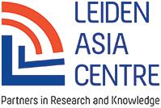
2017-2018
Leiden Asia Year
The LeidenAsiaCentre is one of the partners of the Leiden Asia Year 2017 and helped organize several events with a special focus on East Asia during this year. In close collaboration with the municipality of Leiden, the museums, other organizations and partners in the city, the University organized symposia, conferences, lectures and exhibitions in the city throughout 2017, all on the theme of Asia. The grand opening conference on February 9th was held by the LeidenAsiaCentre.
Data: January 18, 2017
Location: Leiden
Activity: Lecture on North Korean Workers in a Migrant Labor Perspective: Their life, realities and legal issues
Data: February 9, 2017
Location: Stadsgehoorzaal Leiden
Activity: Opening Conference: “China, the Netherlands and Europe”
Data: February 14, , 2017
Location: Leiden
Activity: Meeting with Japanese delegation from IDE-Jetro (gov. affiliated research institute) to discuss possibilities of cooperation on Vietnam)
Data: March 7-8, 2017
Location: Beijing
Activity: Presentation of the reports China and The Netherlands for several Dutch, Chinese and international audiences, organized and hosted by the Dutch Embassy in Beijing
Data: March 27-31
Location: The Hague Centre for Security Studies, Leiden University
Activity: Cyber security
Data: April, 20, 2017
Location: The Hortus, Leiden
Activity: Asia Café (1), In cooperation with: Guanxi, Alumnikai, SVS Alumni
Data: May, 9 2017
Location: TBA, Amsterdam
Activity: Vincent Chang
Data: May, 18 2017
Location: Gemeentemuseum Den Haag
Activity: Symposium ‘Show me China’
Data: May 19, 2017
Location: Den Haag
Activity: Slaves of the System workshop
Data: May 22
Location: TBA, Leiden University
Activity: “Aging Japan” international workshop(1)
Data: June 15-16, 2017
Location: Leiden
Activity: Tibetan Buddhists conference
Data: 15-17 June, 2017
Location: Leiden
Activity: North-Korean posters
Data: June 20, 2017
Location: Amsterdam, Centre for Chinese Traditional Medicine
Activity: Panel discussion on Chinese investments in Europe with Xuefei Knoester-Cao (Confucius Centre, Groningen), Frans Paul van der Putten (Clingendael) en Vincent Chang (fellow, LeidenAsiaCentre)

Data: August 8, 2017
Location: The Hague
Activity: Workshop on South Chinese See Conflict with Ito Go (Meiji University) Hatakeyama Kyoko (Kansai Gaidai University) Lindsay Black (Leiden University)

Data: August 24-25, 2017
Location: Leiden, two days
Activity: Conference: China’s interaction with Global governance(law and economy) , cooperation with the Annual European China Law Studies Conference(ELCS) on August 23/24.
Data: 25-29 September 2017
Location: IIAS/LeidenAsiaCentre, 4-days
Activity: Summer school ‘Asian Food’, in cooperation with Anne Gerritsen and IIAS.
Data: October 16
Location: Leiden
Activity: Public meeting on the CCP Congress 2017 with i.a. Prof. Jorg-Karsten Gottwald, Bochum
Data: October 16
Location: Nieuwspoort, Den Haag
Activity: Haags College by Professor Remco Breuker

Data: October 21-22
Location: Leiden
Activity: CAAS annual conference
21 november ACAF
Data: December 1 and 2 2017
Location: Shanghai
Activity: Cyber security workshop
Data: December 12, 2017 (postponed)
Location: TBA
Activity: “Aging Japan” international seminar/workshop
2018
Data: February 6, 2018
Location: Klein Auditorium, Leiden
Activity: “Slaves to the System: the Global Dimension” report presentation and seminar
Data: February 19, 2018
Location: Pakhuis de Zwijger, Amsterdam
Activity: “Creative Design” Workshop
Data: March 6, 2018
Location: Café Dudok, The Hague
Activity: ACAF: Regional Responses to the Belt and Road Initiative Seminar
Data: March 13, 2018
Location: Wijnhaven, The Hague
Activity: “Partners under Pressure: Civil Society in Dutch Human Rights Policy” report presentation
Data: March 15, 2018
Location: Leiden University
Activity: Book Presentation “Consumption in Post-Bubble Japan” by Kasia Cwiertka and Ewa Machotka
Data: March 19, 2018
Location: Utrecht, together with Utrecht University
Activity: New Silk Road Seminar
Data: April 24, 2018
Location: Scheltema, Leiden
Activity: ‘Aging Japan’ Closing Conference (Previously postponed)
Data: May 4, 2018
Location: Schouwburgstraat, The Hague
Activity: Japanese Constitutional Revision Conference
Data: May 22, 2018
Location: The Hague, De Witte
Activity: Changing Relations between North and South Korea Seminar
Data: May 22-23, 2018
Location: KOG Leiden
Activity: Chinese Internet Research Conference
Data: May 28, 2018
Location: Café Dudok, The Hague
Activity: ACAF: Fake News in Asia Seminar
Data: May 29, 2018
Location: Lipsius, Leiden
Activity: Digital Asia Conference
Data: July 2, 2018
Location: Nieuwspoort, the Hague
Activity: Book presentation “De BV Noord Korea” by Remco Breuker
Data: August 27, 2018
Location: Papendal
Activity: Japanese Paralympics Seminar
Data: September 27, 2018
Location: Nieuwspoort, the Hague
Activity: Chinese Investment Report Presentation

5. Finances
Research and other activities of the LeidenAsiaCentre are made possible through an endowment gift from the VAES ELIAS Fund, administered by the Leiden University Fund (LUF). The centre’s financial, administrative and HR tasks are managed by the Leiden Institute for Area Studies (LIAS/ the Humanities Faculty of Leiden University) with financial oversight provided by Capital Support. The Foundation LeidenAsiaCentre is recognized as an ANBI (charity) by the Dutch Tax Authorities.
Expenses 2016 2017
Research projects (research staff incl.)
and outreach activities 569.797 371.925
Other expenses 2.236 14.830
Total Expenses 572.033 386.755
Income
Vaes-Elias Fund 589.797 442.900
Net result 17.764 56.145

The Supervisory Board has commissioned the Board to implement a long-range research and activity program within the framework of an approved long-range budget. Given the size of the Vaes Elias Fund, the horizon of the LeidenAsiaCentre stretches beyond the mid-twenties.

6. Partners
Societal partners
The LeidenAsiaCentre works together with societal partners in the Netherlands to identify relevant research topics and to formulate the most appropriate – in some cases supplementary – research questions. This will create knowledge that responds to a direct societal need. The Centre itself will be responsible for the research, which will be carried out by independent researchers and other experts and consultants both within and outside of the Netherlands. We also collaborate actively with our partners in disseminating the results of this research.
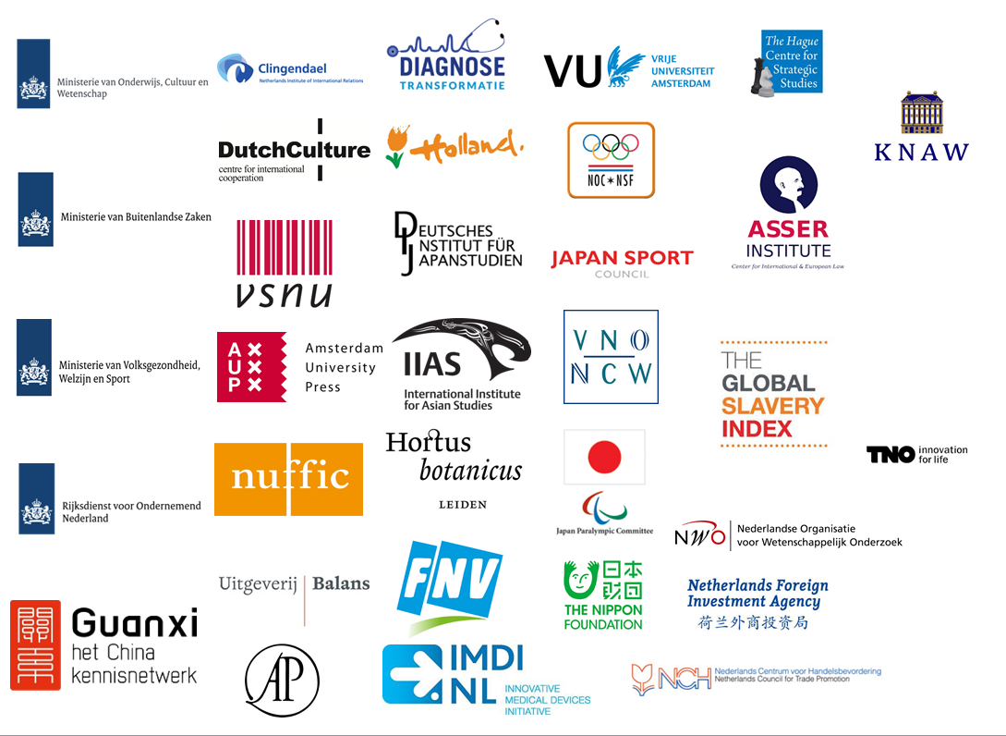
In 2017 so-called sounding boards were organized, consisting of representatives from some of the partner organisations to monitor the research projects.

André van Heemstra (Chair), Douwe Breimer (Treasurer) and Ralph Kröner (Member)
Professors Frank Pieke, Kasia Cwiertka and Remco Breuker

